My Data List
Overview
Once user has formed the query using visual query interface (DAG view), user can execute a query and view the result elements of the query. While navigating through obtained results, user may want to select specific set of result elements for further use.

This functionality allows user to
- Select result elements of interest and add it to data list. These added result elements can then be viewed as a hierarchy of elements representing parent →child relation amongst added element.
- View data set of specific element in the form of spreadsheet view.
- Export the selected data list contents to .csv file
- Apply previously added result element hierarchy to currently selected result elements and it to data list.

Design
The result elements to be added to the data list are hierarchical in nature. For example user might want to save (Gene→UniGene→ GenBankAccession) details to data list and to hold these details we need a data structure which will be hierarchical in nature.

Class Diagram
The class diagram below shows the classes involved in implementing this feature. The details of these classes are listed below.
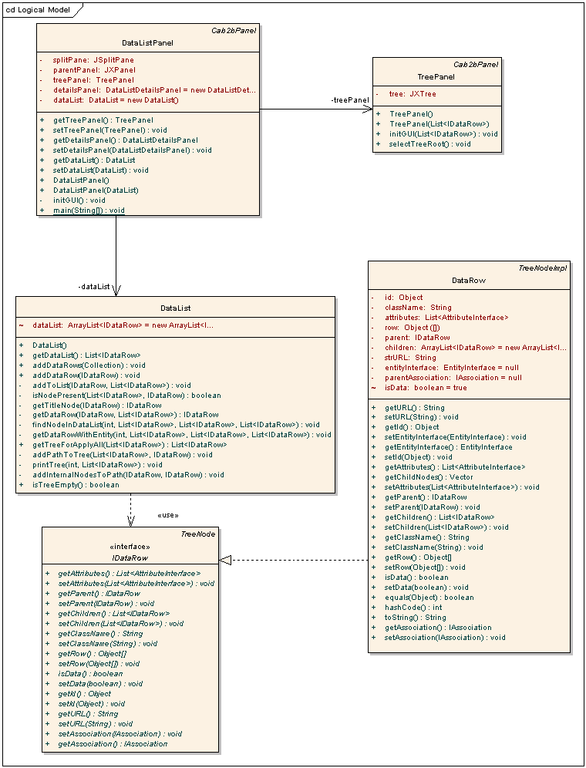

IDataRow: This interface class has methods for setting and getting complete details of a result element. It contains methods to hold the parent child relationship between result elements using which a tree can be easily constructed. It also contains the actual data of the result element. The important methods of this interface are
- getParent / setParent : Gets / sets parent object associated with this IDataRow object
- getChildren / setChildren : Gets / sets children objects associated with this IDataRow object
- getRow / setRow : Gets / sets the data values associated with this IDataRow object
- getAttributes / setAttributes : Gets / sets the attributes (List of AttributeInterface objects) associated with this IDataRow object.

DataRow: This class implements the IDataRow interface.

DataList: This class holds the IDataRow elements using java.util.ArrayList<IDataRow> data structure so that data list hierarchy can be constructed easily. This class contains methods addDataRow / addDataRows for adding result elements to data list. Following are the important methods if this class:
- addDataRow / addDataRows: Add IDataRow elements to data list
- findNodeInDataList: Search IDataRow element in data list hierarchy
- getTreeForApplyAll: Get the tree to be applied to selected result elements

DataListPanel : This class is extended from JPanel and is responsible for displaying the data list elements in the form tree hierarchy. This visual component shows data list element using JTree component nodes. Any node selection in this tree, shows corresponding result elements data as a table. The tree is shown by adding TreePanel instance to this panel. The data set of selected node is shown using JTable.

TreePanel: This class creates tree using DataList class.

Sequence Diagram
The diagram below shows the sequence of the event fired for adding/view result elements to data list.
